Course: Web Application Development
Lab Instructor: Dr. Le Duy Tan
Email: ldtan@hcmiu.edu.vn

Lab 5 - Web Session using Cookies

Content:
- Definitions.
- Sending cookies to browser
- Reading cookies from browser
- Simple cookie-handling Servlets
- Practices and Exercises

Duration: 3 hours

Part 1: Definitions

What is Cookies?
A message given to a web browser by a web server. The browser stores the message in a text file. The message is then sent back to the server each time the browser requests a page from the server.
The main purpose of cookies is to identify users and possibly prepare customized web pages for them. When you enter a website using cookies, you may be asked to fill out a form providing such information as your name and interests. This information is packaged into a cookie and sent to your web browser which stores it for later use. The next time you go to the same website, your browser will send the cookie to the webserver. The server can use this information to present you with custom webpages. So, for example, instead of seeing just a generic welcome page you might see a welcome page with your name on it.

What is a Session?
A Session refers to all the request that a single client makes to a server. A session is specific to the user and for each user a new session is created to track all the request from that user. Every user has a separate session and separate session variable is associated with that session. In case of web application, the default time-out value for session variable is 20 minutes, which can be changed as per the requirement.

What is Session cookies?
Also called a transient cookie, a cookie that is erased when the user closes the web browser. The session cookie is stored in temporary memory and is not retained after the browser is closed. Session cookies do not collect information from the user’s computer. They typically will store information in the form of a session identification that does not personally identify the user.

What is Persistent cookies?
Also called a permanent cookie, or a stored cookie, a cookie that is stored on a user’s hard drive until it expires (persistent cookies are set with expiration dates) or until the user deletes the cookies. Persistent cookies are used to collect identifying information about the user, such as web surfing behavior or user preferences for a specific website.
Part 2: Sending Cookies to client (browser)
Following 3 steps below:
- Creating a Cookie object. You call the Cookie constructor with a cookie name and a cookie value, both of which are strings.
Example: Cookie c = new Cookie("userID", "a1234");
- Setting the maximum age. If you want the browser to store the cookie on disk instead of just keeping it in memory, you use setMaxAge to specify how long (in seconds) the cookie should be valid.
Example: c.setMaxAge(60*60*24*7); // One week
- Placing the Cookie into the HTTP response headers. You use response.addCookie to accomplish this. If you forget this step, no cookie is sent to the browser!
Example: response.addCookie(c);

Part 3: Reading Cookies from the client (browser)

Following 2 steps:
- Call request.getCookies. This yields an array of Cookie objects.
- Loop down the array, calling getName on each one until you find the cookie of interest. You then typically call getValue and use the value in some application-specific way.
Loop Down the Cookie Array:
Once you have the array of cookies, you typically loop down it, calling getName on each Cookie until you find one matching the name you have in mind. Remember that cookies are specific to your host (or domain), not your servlet (or JSP page). So, although your servlet might send a single cookie, you could get many irrelevant cookies back. Once you find the cookie of interest, you typically call getValue on it and finish with some processing specific to the resultant value. For example:
String cookieName = "userID";
Cookie[] cookies = request.getCookies();
if (cookies != null) {
for(int i=0; i<cookies.length; i++) {
Cookie cookie = cookies[i];
if (cookieName.equals(cookie.getName())) {
doSomethingWith(cookie.getValue());
}
}
}
Part 4: Simple cookie-handling Servlets
Click File -> New Project. Chose Samples\Web on the categories and choose Servlet Example -> Next -> Finish (pls go to google site without Samples directory)
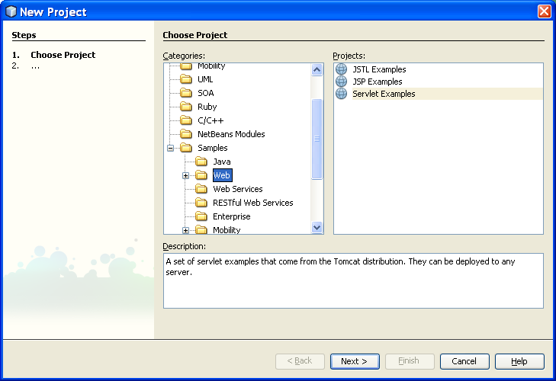

The project is created automatically. Choose the file CookieExample.java, look at the source code:
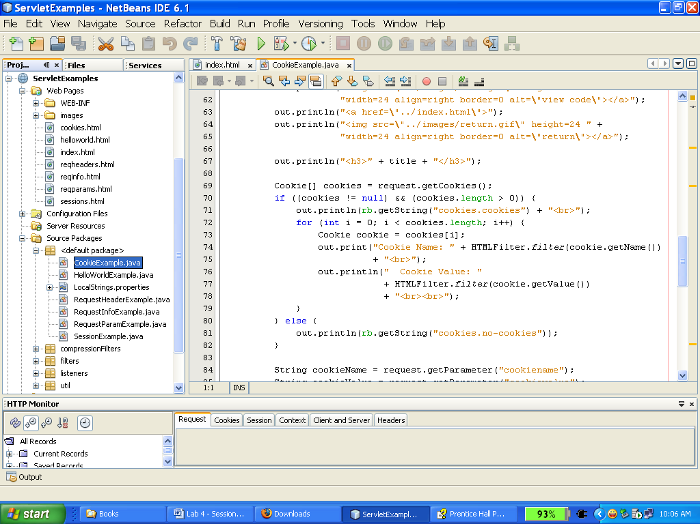

This is the interface when we run project on browser
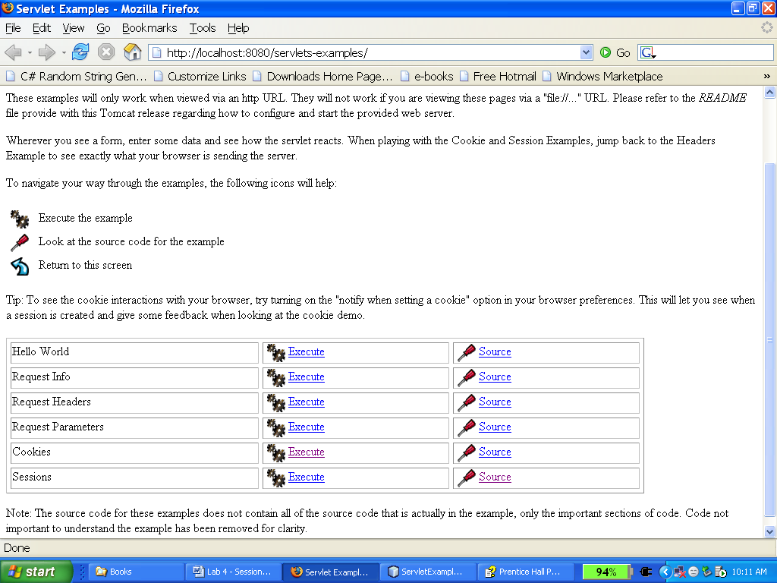

Part 5: Examples

Example 1:

Explore all methods of cookie and session by:
- create a web project
- create a Servlet
- declare an object Cookies cookie -> cookie. ?
- declare an object HttpSession session -> session. ?

Example 2:
Open source code of Cookies and Session from ServletExample and modify Cookies:
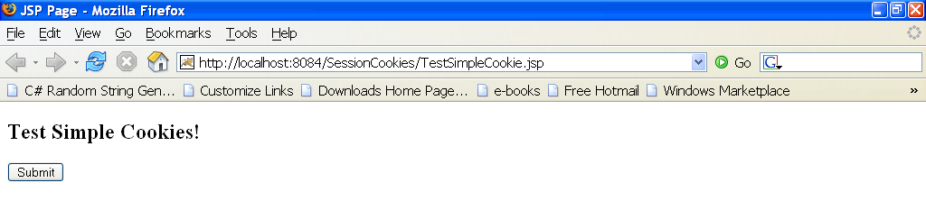
Create a servlet with name SimpleCookie.java, modify source code below:
PrintWriter out;
response.setContentType(“text/html”);
out = response.getWriter();
Cookie cookie = new Cookie(“Cookies_Name”, “123456”);
cookie.setMaxAge(100);
response.addCookie(cookie);
This is the result on browser:
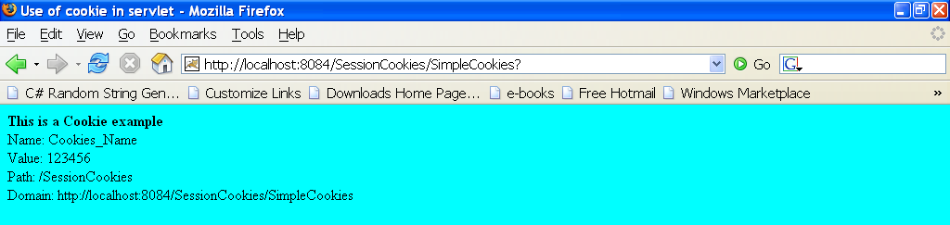

Example 3:

Design a form like this:
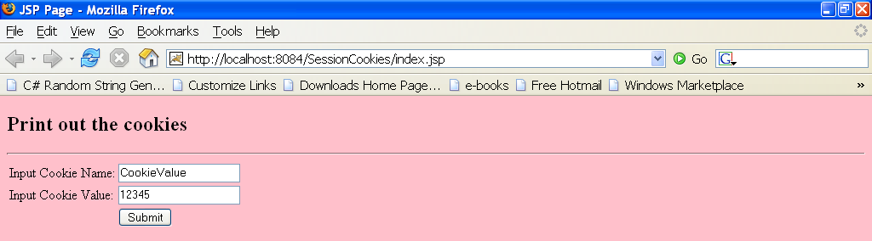

Copy the following source code and modify:
public class CookieExample extends HttpServlet {

public void doGet(HttpServletRequest request, HttpServletResponse response)
throws IOException, ServletException
{
response.setContentType(“text/html”);
PrintWriter out = response.getWriter();

// print out cookies

Cookie[] cookies = request.getCookies();
for (int i = 0; i < cookies.length; i++) {
Cookie c = cookies[i];
String name = c.getName();
String value = c.getValue();
out.println(name + “ = “ + value);
}

// set a cookie

String name = request.getParameter(“cookieName”);
if (name != null && name.length() > 0) {
String value = request.getParameter(“cookieValue”);
Cookie c = new Cookie(name, value);
response.addCookie©;
}
}
}

This is the result:
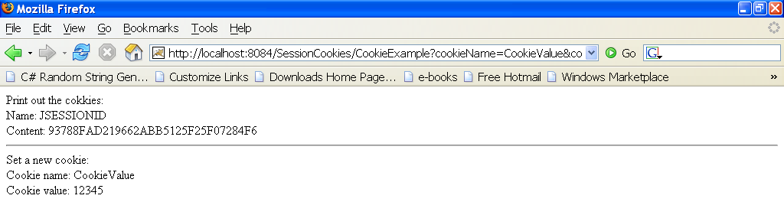

Go to browser click Tool -> Option - > Cookies -> View Cookies to check information of name and value which is sent to browser.
Exercise 3: Base on chapter 8 in the text-book (8.5 Using Cookies to Detect First-Time Visitors) copy source code and modify to create a cookie:

This is the first running, counter = 0.
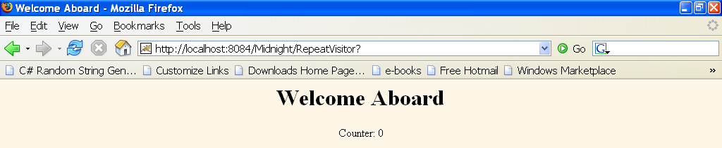
This is the result when click “Refresh” button, counter = 1.
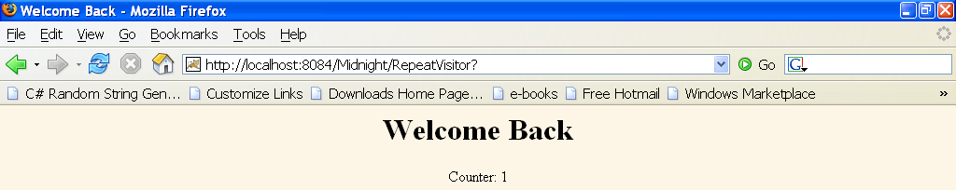
Exercise 4: Refer example “Listing 9.1 ShowSession.java” from text-book, you can modify source code to understand session.
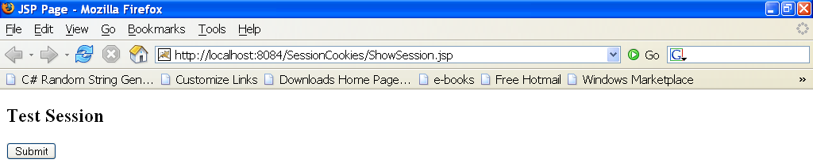
The first running on browser:
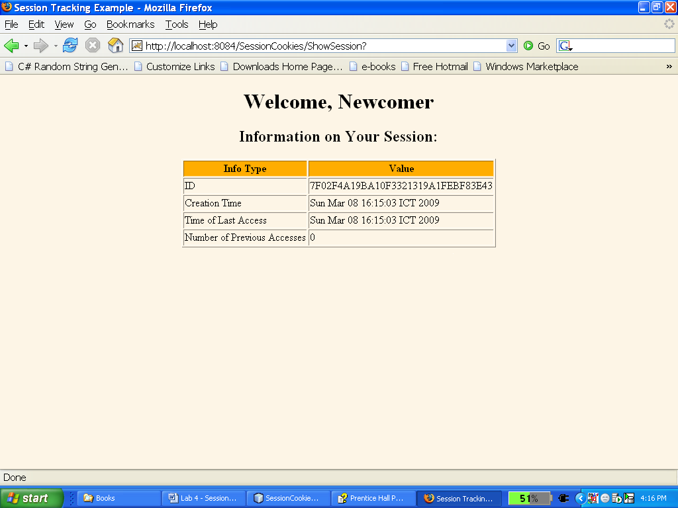
The next time (refresh button):
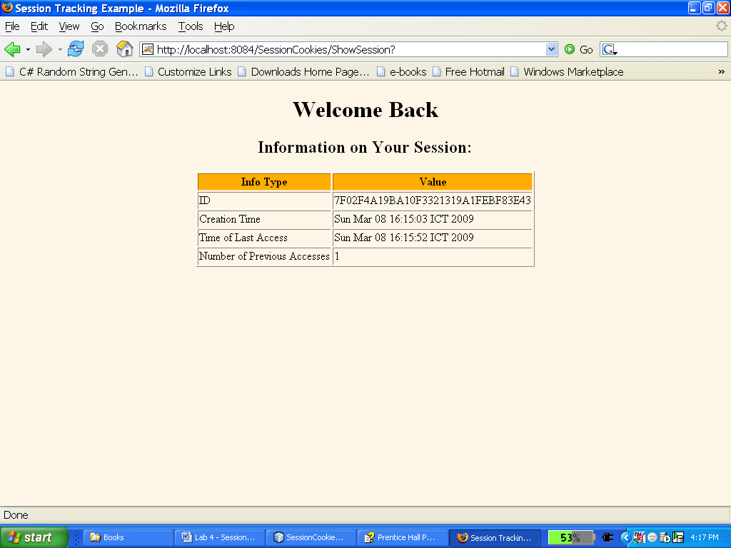

Extra Exercise:
Implementation of “Keep me logged in” feature

You are required to do the following tasks to implement a feature of an e-commerce website:

- Create a graphical user interface of login window (user name, password and login button) using HTML and CSS.

- Implement a Cookie to store user name and password of user. After the first login, your browser will be able to remember your user name and password. Closing your browser and opening it again, your browser should recognize your identification without logging in.

- Encrypt the cookie using AES-256. The Advanced Encryption Standard (AES) is an encryption algorithm for securing electronic data established by the U.S National Institute of Standards and Technology. To prevent unauthorized access of user name and password stored in Cookies, you need to encrypt the Cookies using a reliable encryption standard AES-256.

